 **COMSATS UNIVERSITY ISLAMABAD ATTOCK CAMPUS**

|  |  |
| --- | --- |
| Student Name | Afaq Ahmed |
| Registration Number | SP20-BSE-029 |
| Program | BS-(SE) |
| Semester | VI |

**Mobile Application Development**

**ASSIGNMENT# 02**

**Design the Ludo screen in React native. Reference image is available in shared folder.**

**Upload the screen shot of your design in your repo.**



* **Code**

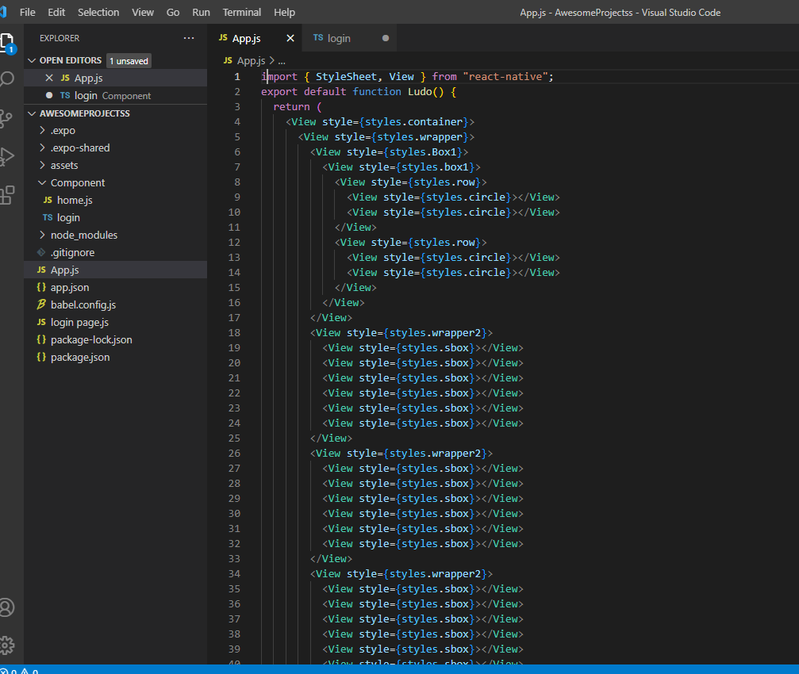

* **Out put**

